May 15, 2019

This is a summary document for LCR sampling through the end of the winter 2018-2019 sampling

Take home: Y_SM has been the most consistent site in terms of variance less than mean and similar densities. N_SM has highest variance. Y_NA and N_NA are similar in mean and have high which will make it very difficult to detect differences with large statistical power.

Next steps will be re-do the GLM analyses using counts as the response and controlling for effort as an offset. This will be done across all epochs and then will develop a new analyses for a within epoch comparison for winter 2018-2019. Working to develop covariates for use in within epoch comparison including salinity and elevation. I have completed two different types of analyses on these data so far and am evaluating these approaches. I will also be working to extend the size frequency analyses to the count data to convert the oyster counts to counts per size group. I’ll then re-do these graphs and the GLM analyses by size category to try and develop an understanding as to whether the variation is driven by differences in size of oysters. Finally, the power analyses needs to be done differently because the strata appear to have different distributions. There are a couple of different ways to address this and I am trying to learn as much as I can about these different approaches to have this analyses done before the fall sampling starts. I am hoping we can contract with Dan Gwinn for some help with this. Dan has thought about these types of issues a lot and has some really good ideas on how to address them from a simulation and analytical framework. Here is a link to Dan’s page <https://dgwinn.wordpress.com/quantitative-tools-for-ecological-problems/>

To review the naming, we are sampling with strata defined by whether the area is open or closed to fishing (Y/N) or the status of rocks (Large [LG], Small [SM], or wild without rocks [NA].

Possible strata

Strata Description

N_LG No harvest, large rock

N_NA No harvest, no rock (wild bar)

N_SM No harvest, small rock

Y_NA Yes harvest, no rock

Y_SM Yes harvest, small rock (has not been sampled)

Y_LG Yes harvest, large rock (not a possibility as large rocks only used in closed harvest areas)

Table 1. Data table of the winter 2018-2019 data from the “collapsed” transects (data1 from data processing script). A transecti is a collapsed transect when multiple transects on an individual bar are pooled, even if collected across multiple days.

|  |  |  |  |  |  |  |  |  |  |  |  |
| --- | --- | --- | --- | --- | --- | --- | --- | --- | --- | --- | --- |
| **Line** | **Season** | **Treatment** | **Local** | **Site** | **Bar** | **Station** | **Count (live)** | **Transect length (m)** | **Area (m^2)** | **Oyster density/m^2** | **Strata** |
| 1 | Winter | control | BT | I | 1 | BTI1 | 897 | 23 | 3.51 | 255.91 | N_NA |
| 2 | Winter | control | BT | I | 2 | BTI2 | 1108 | 38.65 | 5.89 | 188.11 | N_NA |
| 3 | Winter | control | BT | I | 3 | BTI3 | 1326 | 39.9 | 6.08 | 218.06 | N_NA |
| 4 | Winter | control | BT | I | 4 | BTI4 | 627.5 | 55.8 | 8.5 | 73.79 | N_NA |
| 5 | Winter | control | BT | I | 5 | BTI5 | 3988 | 62.69 | 9.55 | 417.42 | N_NA |
| 6 | Winter | control | BT | I | 6 | BTI6 | 815.5 | 17.75 | 2.71 | 301.47 | N_NA |
| 7 | Winter | control | LC | I | 1 | LCI1 | 1650 | 45.39 | 6.92 | 238.53 | N_NA |
| 8 | Winter | control | LC | I | 10 | LCI10 | 1686 | 38.2 | 5.82 | 289.61 | Y_NA |
| 9 | Winter | control | LC | I | 11 | LCI11 | 302 | 17.86 | 2.72 | 110.95 | Y_NA |
| 10 | Winter | control | LC | I | 12 | LCI12 | 1106 | 36.09 | 5.5 | 201.09 | Y_NA |
| 11 | Winter | control | LC | I | 13 | LCI13 | 3421.5 | 71.3 | 10.87 | 314.88 | Y_NA |
| 12 | Winter | control | LC | I | 14 | LCI14 | 1501 | 22.75 | 3.47 | 432.93 | Y_NA |
| 13 | Winter | control | LC | I | 15 | LCI15 | 638 | 20.8 | 3.17 | 201.27 | Y_NA |
| 14 | Winter | control | LC | I | 16 | LCI16 | 427.5 | 24.04 | 3.66 | 116.69 | Y_NA |
| 15 | Winter | control | LC | I | 17 | LCI17 | 189 | 14.65 | 2.23 | 84.65 | Y_NA |
| 16 | Winter | control | LC | I | 18 | LCI18 | 1813 | 68.16 | 10.39 | 174.54 | Y_NA |
| 17 | Winter | control | LC | I | 19 | LCI19 | 153 | 22.21 | 3.38 | 45.2 | Y_NA |
| 18 | Winter | control | LC | I | 2 | LCI2 | 1534 | 32.2 | 4.91 | 312.6 | Y_NA |
| 19 | Winter | control | LC | I | 3 | LCI3 | 1104 | 23.8 | 3.63 | 304.37 | Y_NA |
| 20 | Winter | control | LC | I | 4 | LCI4 | 1909 | 22.5 | 3.43 | 556.72 | Y_NA |
| 21 | Winter | control | LC | I | 5 | LCI5 | 942 | 20.4 | 3.11 | 303 | Y_NA |
| 22 | Winter | control | LC | I | 6 | LCI6 | 454 | 21.5 | 3.28 | 138.56 | Y_NA |
| 23 | Winter | control | LC | I | 7 | LCI7 | 853 | 21.66 | 3.3 | 258.41 | N_NA |
| 24 | Winter | control | LC | I | 8 | LCI8 | 96 | 19 | 2.9 | 33.15 | Y_NA |
| 25 | Winter | control | LC | I | 9 | LCI9 | 695 | 22.24 | 3.39 | 205.05 | Y_NA |
| 26 | Winter | control | LC | N | 1 | LCN1 | 109 | 29.86 | 4.55 | 23.95 | Y_NA |
| 27 | Winter | control | LC | N | 2 | LCN2 | 693 | 32.77 | 4.99 | 138.76 | Y_NA |
| 28 | Winter | control | LC | N | 3 | LCN3 | 146 | 19.9 | 3.03 | 48.14 | Y_NA |
| 29 | Winter | control | LC | N | 4 | LCN4 | 35 | 22 | 3.35 | 10.44 | Y_NA |
| 30 | Winter | control | LC | N | 5 | LCN5 | 700 | 21.75 | 3.31 | 211.18 | Y_NA |
| 31 | Winter | control | LC | N | 6 | LCN6 | 2275 | 32.4 | 4.94 | 460.74 | Y_NA |
| 32 | Winter | control | LC | N | 7 | LCN7 | 611 | 13.3 | 2.03 | 301.44 | Y_NA |
| 33 | Winter | control | LC | N | 8 | LCN8 | 58 | 17.5 | 2.67 | 21.75 | Y_NA |
| 34 | Winter | control | LC | N | 9 | LCN9 | 4 | 36.12 | 5.5 | 0.73 | Y_NA |
| 35 | Winter | rocks | LC | O | 10A | LCO10A | 1619 | 113.4 | 17.28 | 93.68 | N_LG |
| 36 | Winter | rocks | LC | O | 11B | LCO11B | 276 | 66.77 | 10.18 | 27.12 | N_LG |
| 37 | Winter | rocks | LC | O | 12 | LCO12 | 358.5 | 111.86 | 17.05 | 21.03 | N_LG |
| 38 | Winter | rocks | LC | O | 13 | LCO13 | 3678 | 62.55 | 9.53 | 385.83 | N_SM |
| 39 | Winter | rocks | LC | O | 14 | LCO14 | 4612 | 70.11 | 10.68 | 431.64 | N_SM |
| 40 | Winter | rocks | LC | O | 15 | LCO15 | 3390.5 | 169.84 | 25.88 | 130.99 | N_SM |
| 41 | Winter | rocks | LC | O | 16 | LCO16 | 301.5 | 68.91 | 10.5 | 28.71 | N_SM |
| 42 | Winter | rocks | LC | O | 17 | LCO17 | 209 | 45.37 | 6.91 | 30.23 | Y_SM |
| 43 | Winter | rocks | LC | O | 19 | LCO19 | 557.5 | 116.31 | 17.73 | 31.45 | Y_SM |
| 44 | Winter | rocks | LC | O | 2 | LCO2 | 945 | 20.86 | 3.18 | 297.26 | N_LG |
| 45 | Winter | rocks | LC | O | 20 | LCO20 | 385 | 87.12 | 13.28 | 29 | Y_SM |
| 46 | Winter | rocks | LC | O | 21 | LCO21 | 714 | 129.01 | 19.66 | 36.32 | Y_SM |
| 47 | Winter | rocks | LC | O | 3 | LCO3 | 358 | 18.02 | 2.75 | 130.36 | N_LG |
| 48 | Winter | rocks | LC | O | 4 | LCO4 | 953 | 22.1 | 3.37 | 282.95 | N_LG |
| 49 | Winter | rocks | LC | O | 8A | LCO8A | 319 | 15.2 | 2.32 | 137.71 | N_LG |
| 50 | Winter | rocks | LC | O | 9B | LCO9B | 674.5 | 115.78 | 17.64 | 38.23 | N_LG |
| 51 | Winter | rocks | LC | O | 9C | LCO9C | 1161 | 111.2 | 16.95 | 68.51 | N_LG |
| 52 | Winter | control | LT | I | 1 | LTI1 | 692 | 29.8 | 4.54 | 152.37 | N_NA |
| 53 | Winter | control | LT | I | 2 | LTI2 | 190 | 22.68 | 3.46 | 54.97 | N_NA |
| 54 | Winter | control | LT | I | 3 | LTI3 | 883 | 37.5 | 5.71 | 154.51 | N_NA |
| 55 | Winter | control | LT | I | 4 | LTI4 | 1323 | 34.84 | 5.31 | 249.17 | N_NA |
| 56 | Winter | control | LT | I | 5 | LTI5 | 1412 | 38.75 | 5.91 | 239.1 | N_NA |
| 57 | Winter | control | LT | I | 6 | LTI6 | 594 | 18.87 | 2.88 | 206.55 | N_NA |
| 58 | Winter | control | NN | I | 1 | NNI1 | 233.5 | 14.5 | 2.21 | 105.67 | N_NA |
| 59 | Winter | control | NN | I | 2 | NNI2 | 911 | 22.85 | 3.48 | 261.61 | N_NA |
| 60 | Winter | control | NN | I | 3 | NNI3 | 156 | 33 | 5.03 | 31.02 | N_NA |
| 61 | Winter | control | NN | I | 4 | NNI4 | 571 | 13.3 | 2.03 | 281.71 | N_NA |

Table 2. Transect length sampled (m) by strata

|  |  |
| --- | --- |
| **Strata** | **Total transect length sampled (m)** |
| N_LG | 595.19 |
| N_NA | 570.93 |
| N_SM | 371.41 |
| Y_NA | 723.3 |
| Y_SM | 377.81 |

Table 3. Counts of individual (not collapsed) transects by strata.

|  |  |
| --- | --- |
| **Strata** | **Frequency** |
| N_LG | 27 |
| N_NA | 25 |
| N_SM | 14 |
| Y_NA | 29 |
| Y_SM | 20 |

Table 4. Total number of collapsed transects. This totals 61 which are the 61 rows in Table 1.

|  |  |
| --- | --- |
| **Strata** | **Frequency** |
| N_LG | 9 |
| N_NA | 18 |
| N_SM | 4 |
| Y_NA | 26 |
| Y_SM | 4 |

Table 5. Mean length (m) of collapsed transects. Transect width is constant so is simply a scaler.

|  |  |
| --- | --- |
| **Strata** | **Mean transect length (m)** |
| N_LG | 66.13 |
| N_NA | 31.72 |
| N_SM | 92.85 |
| Y_NA | 27.82 |
| Y_SM | 94.45 |

Table 6. Variance in length (m) of collapsed transects.

|  |  |
| --- | --- |
| **Strata** | **Variance transect length (m)** |
| N_LG | 2214.87 |
| N_NA | 192.5 |
| N_SM | 2645.26 |
| Y_NA | 196.97 |
| Y_SM | 1378.28 |

Table 7. Simple summary stats by strata of oyster density (per m^2) by strata. The L95CI and U95CI are based on a t-distribution while the L95bstrap and U95bstrap are bootstrap based confidence intervals.

|  |  |  |  |  |  |  |  |  |  |  |  |  |
| --- | --- | --- | --- | --- | --- | --- | --- | --- | --- | --- | --- | --- |
| **Strata** | **Number transects** | **Mean** | **Median** | **SD** | **Var** | **CV** | **SE** | **L95CI** | **U95CI** | **Bstrapmean** | **L95bstrap** | **U95bstrap** |
| N_LG | 9 | 121.87 | 93.68 | 104.17 | 10851.91 | 0.85 | 34.72 | 53.81 | 189.93 | 122.51 | 65.08 | 188.77 |
| N_NA | 18 | 204.91 | 228.3 | 96.66 | 9343.42 | 0.47 | 22.78 | 160.25 | 249.57 | 205.49 | 163.48 | 248.41 |
| N_SM | 4 | 244.29 | 258.41 | 195.32 | 38148.41 | 0.8 | 97.66 | 52.88 | 435.7 | 243.06 | 79.85 | 408.74 |
| Y_NA | 26 | 193.94 | 187.81 | 150.2 | 22560.33 | 0.77 | 29.46 | 136.2 | 251.67 | 194.59 | 139.99 | 255.93 |
| Y_SM | 4 | 31.75 | 30.84 | 3.21 | 10.28 | 0.1 | 1.6 | 28.61 | 34.89 | 31.72 | 29.61 | 34.8 |

Comment: This is an important table. Note I calculate t-distribution based confidence intervals (standard parametric confidence intervals which assume normality) and bootstrap confidence intervals. That is because density is not normally distributed for these strata. That is why I calculate bootstrap mean and confidence intervals. Another key point to look at is how much larger the variance is than the mean for each strata.



Figure 1. Oyster density (m^2) by station (different rows) with unique colors and shape coded by strata for winter 2018/2019 sampling.

Comment: This is an important figure because it shows the “spread” within each strata (shape and color) that is driven by the different stations within each strata (each line of the graph on the y-axis). As an example, for Y_NA the density estimates are highly variable, that’s why there is a huge spread. Compare that to Y_SM (only 4 samples taken). N_NA seems to perhaps be falling out a little bit between BTI complex and NN/LT complex. You can sort of see this bifurcation in the histogram in the next plot. This is where the spatial autocorrelation in the samples will be important to incorporate.



Figure 2. Histogram of oyster density (m^2) in each collapsed transect by strata for winter 2018/2019 sampling.



Figure 3. Box plot of oyster density (m^2) by strata for winter 2018/2019 sampling.

Comment: I turned this box plot “on its side” so density is on the “x” and the graph orients such that zero is bottom left. Other box plot aspects are the same as traditional box plots. The shape of these box plots is very informative. Remember how to interpret a box plot as the tails are not confidence intervals. The top/bottom of the box tells you that 25% of the data are greater or less than this value. So, the top of the box is the upper quartile and the bottom of the box is the lower quartile. The median line inside the box (thick black line) tells you that 50% of the data are greater or less than this value. The top/bottom of the whisker are the greatest value excluding outliers. Outliers are defined as dots above the whisker and those are 1.5 times the upper quartile.

Table 7, Figure 1, and Figure 3 are really presenting the same information in different ways on a key issue – the amount of variability and how this variability compares to the mean for oyster counts within each strata. Why are the strata so variable? Are there biological or geological reasons within a strata such as salinity, or shell density, or elevation? Maybe if we looked at a different value such as density of oyster tissue these variations would be different than they are for numbers of oysters? What if we restructure these analyses to be only certain size classes of oysters?

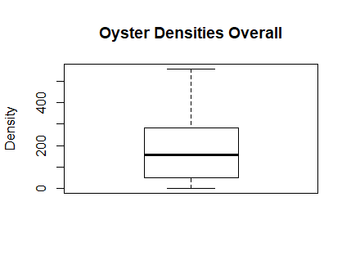

Figure 4. Boxplot of density (oysters/m^2) overall for winter 2018/2019 sampling.

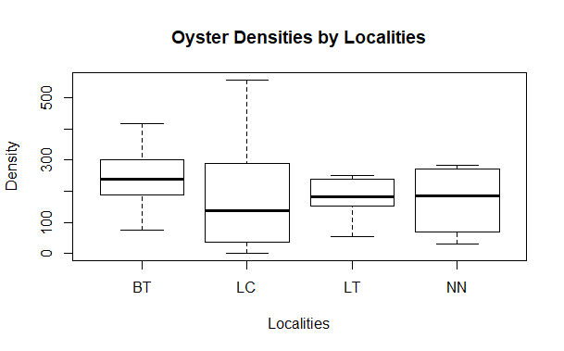

Figure 5. Boxplot of oyster density (oysters/m^2) by locality for winter 2018/2019 sampling.

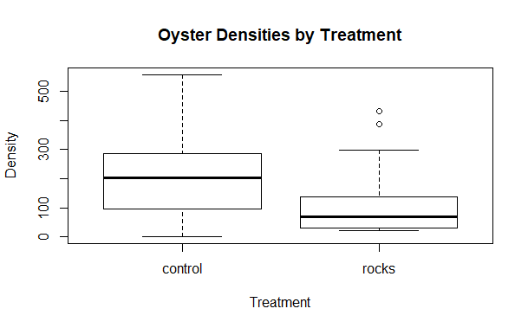

Figure 6. Boxplot of oyster density (oysters/m^2) by treatment for winter 2018/2019 sampling.

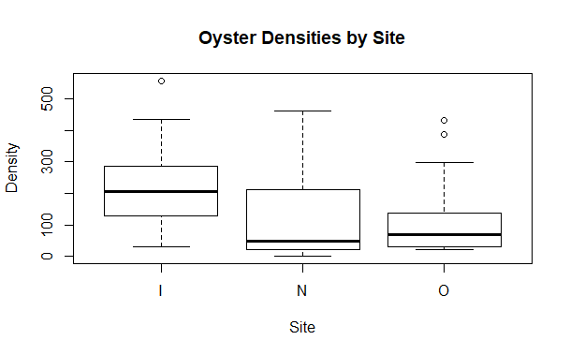

Figure 7. Boxplot of oyster density (oysters/m^2) by site for winter 2018/2019 sampling.



Figure 9. Histograms of collapsed transect length (m) by locality for winter 2018/2019 sampling.



Figure 10. Histogram of collapsed transect lengths (m) by strata for winter 2018/2019 sampling.